LangGraph Core Concepts
Course: CampusX - Agentic AI using LangGraph
Lesson: Video 4 - LangGraph Core Concepts
Duration: 51 minutes 52 seconds
Watch: https://www.youtube.com/watch?v=D5KhiCDM9XQ

At a glance: what you will learn
LangGraph lets you represent multi-step AI behavior as a directed graph. Nodes perform tasks; edges decide what runs next; a shared state holds data; reducers control how updates combine; the runtime executes the graph in supersteps. The lesson first introduces five useful LLM workflow patterns, then explains the underlying graph architecture.
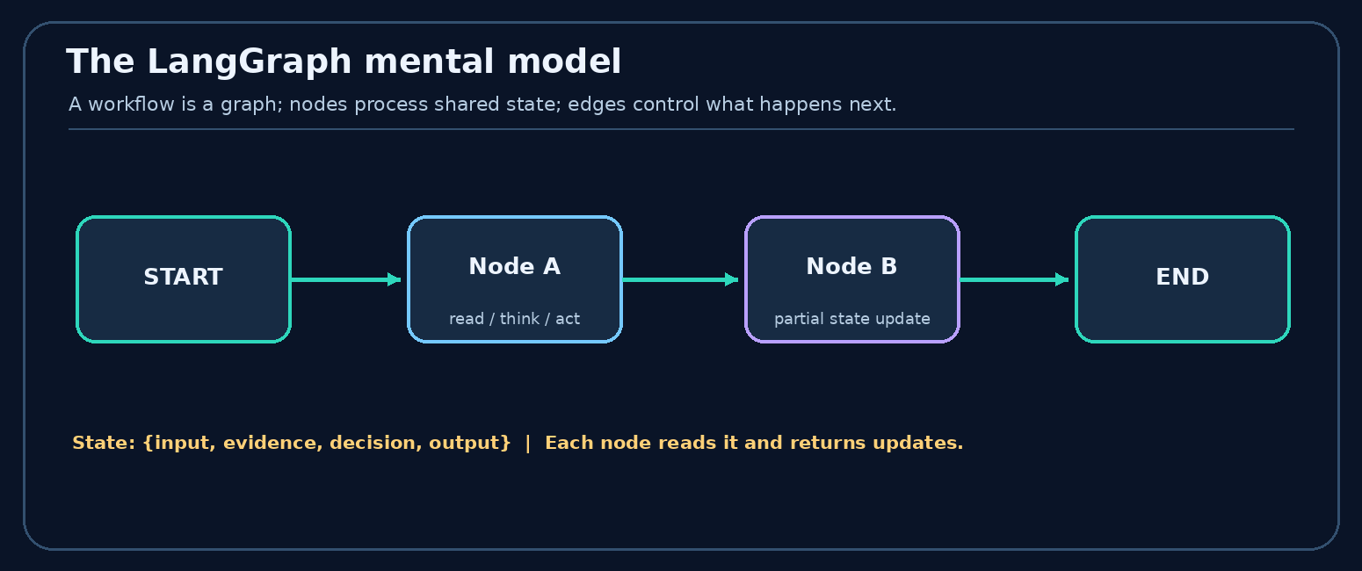
Figure 1. A simple mental model for nodes, edges and shared state

Beginner’s analogy: a team passing a shared notebook
Imagine an essay-review team. One person writes a draft, several people grade it, and another decides whether it is good enough. Nodes are team members; edges are instructions for who works next; state is the shared notebook; a reducer describes how to merge several reviewers’ notes; and the runtime coordinates the handoffs.
This model is useful because it separates three concerns: work (a node), control (an edge), and data (state). In a graph, those concerns are visible and testable.

Learning goals
After these notes, you should be able to draw the five core workflow patterns, explain a reducer with a real state update, build a conditional router, and describe what happens in one parallel execution round.

Video chapter bookmarks
00:00 - Introduction
01:14 - What is LangGraph?
05:43 - LLM workflows
09:07 - Prompt chaining
11:17 - Routing
13:14 - Parallelization
16:11 - Orchestrator-workers
19:48 - Evaluator-optimizer
23:00 - Graphs, nodes and edges
30:53 - State
36:07 - Reducers
44:38 - Execution model

1. What is LangGraph? 01:14
LangGraph is a framework for orchestrating stateful, multi-step applications and agents. Instead of one giant function or prompt, describe a process as connected tasks with explicit transitions. A node can call an LLM, retrieve a document, run ordinary Python, consult a tool or evaluate a result; not every node needs an LLM.
Why use a graph? Linear chains are convenient for fixed steps, but realistic applications also need routing, parallel work, retry loops, state tracking, inspection, and sometimes pausing and resuming. The graph model makes those execution paths explicit.
Remember: LangGraph does not make the model intelligent by itself. It gives your application a controllable way to organize steps, data, and decisions.

2. What is an LLM workflow? 05:43
A workflow is an organized set of tasks aimed at a result. An LLM workflow includes one or more tasks involving language models, often mixed with deterministic code and tools. A research assistant might classify a question, retrieve evidence, summarize it, score the summary, and either return or revise the answer.
- Sequential: A -> B -> C (outline, draft, polish).
- Conditional: A selects B or C (a billing issue reaches the billing specialist).
- Parallel: A fans out to B and C (several independent checks).
- Iterative: A and B repeat (generate, critique, improve).

Five patterns covered in the lesson
The following patterns are ways to organize work. They can be combined within one application.

Workflow vs agent (important distinction)
A workflow usually follows designed code paths: the developer determines the overall sequence, branches and stop rules. An agent dynamically chooses actions, tools or subtasks within allowed boundaries. The same application may have deterministic workflow nodes and agentic nodes.
Example: A document processor always runs extract → classify → validate (workflow). If validation fails, a model may choose which specialist tool to use to repair the document (agentic behavior). LangGraph can represent both.
Design question: If you can specify exactly which steps are needed, prefer a predictable workflow. Give an agent more freedom only where that flexibility adds value.

3. Prompt chaining 09:07
Idea: Split a task into smaller fixed stages. Output from one stage becomes input to the next. For example: user request -> create outline -> write draft -> validate -> final answer.
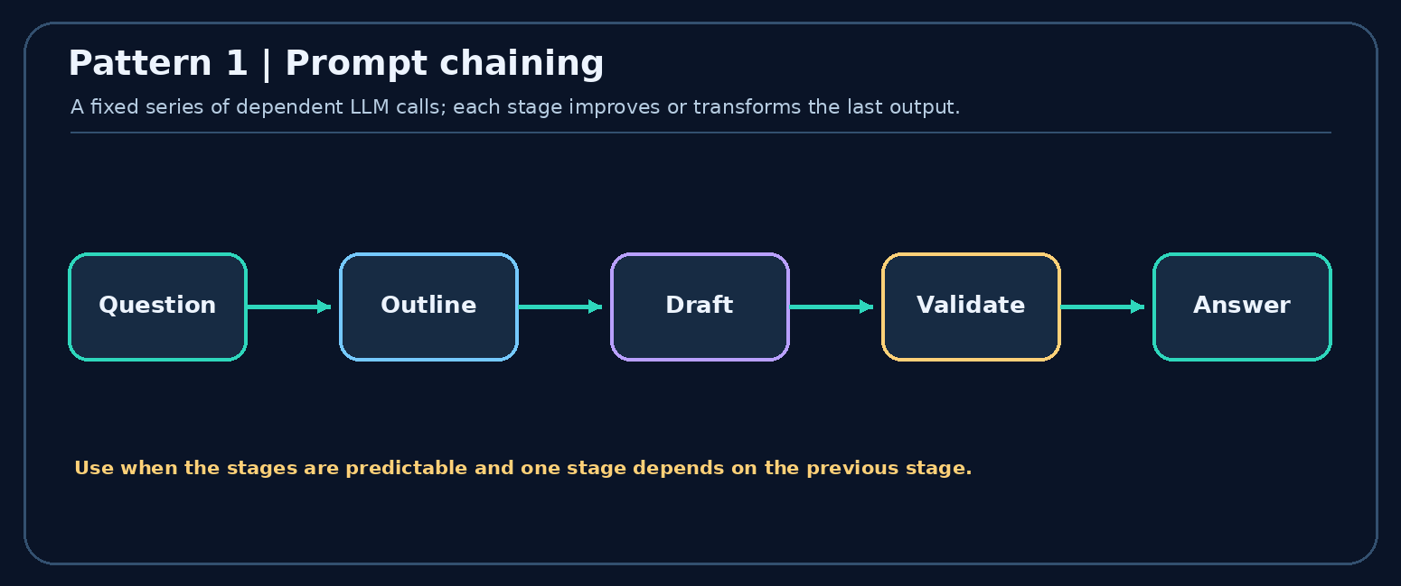
Figure 2. Prompt chaining: a fixed sequence of dependent calls
When useful: the subtasks and their order are predictable; you want validation checkpoints; a single huge prompt performs poorly. Trade-off: serial calls add latency and errors can propagate through later steps. A simple sequential graph is enough; an advanced agent is not required.
Step-by-step example - preparing a blog article:
- Planner receives topic="Vector databases" and returns an outline.
- Writer receives that outline and returns a draft with headings and explanations.
- Editor receives the draft and returns a polished article.
- A deterministic quality gate checks required sections; failures may be reported instead of silently passing.
Each step has a narrower responsibility, making errors easier to locate. But a failed outline can affect every downstream step; gates and structured outputs reduce this risk.
When to avoid: if the task is trivial, three LLM calls may increase latency and cost without a meaningful quality benefit.

4. Routing 11:17
Idea: Inspect an input and send it to the right handler. A customer support assistant can route refund questions to billing, error reports to technical support, and pricing to sales. The decision may come from a deterministic rule or an LLM classifier.
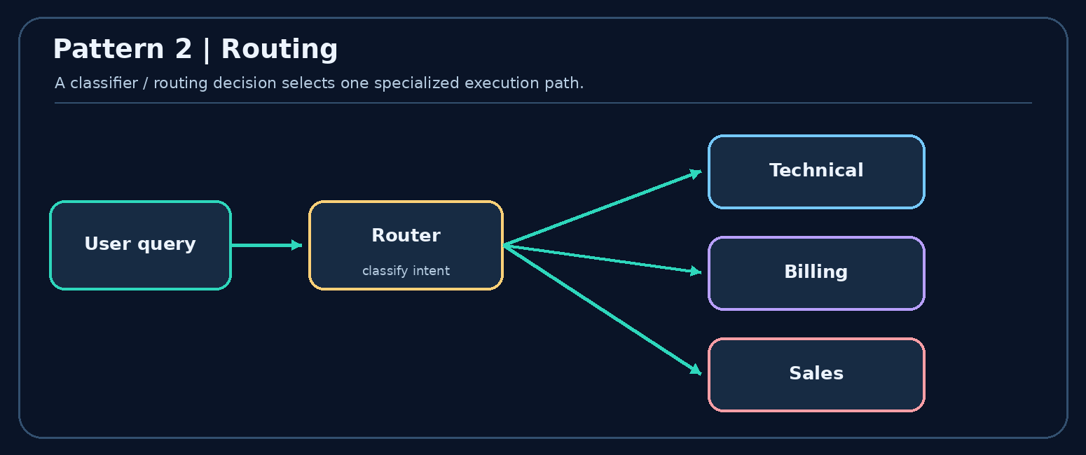
Figure 3. Routing: one input chooses among specialist paths
Difference from chaining: chaining normally runs the same known steps each time; routing selects which path to run. Real applications often route first, then run a smaller chain within the chosen path.
Worked router: input "My card was charged twice" → classifier predicts billing → billing-specific node runs → its reply is returned. If the router predicts technical, only the technical branch runs. The next step is selected by control flow, not by copying an entire graph for every request.
Router design rules: make categories mutually understandable, provide a fallback for uncertain classifications, and test ambiguous inputs such as "Billing page is broken". A model classifier can be wrong, so sensitive actions should still have validation.
In code, a StateGraph typically uses add_conditional_edges(...) to map route labels to destination node names.

5. Parallelization 13:14
Idea: Run independent checks at the same time, then aggregate the results. For content moderation, one worker checks safety, another checks factual claims, and another checks policy compliance. A merge step combines their findings into a publish-or-review decision.
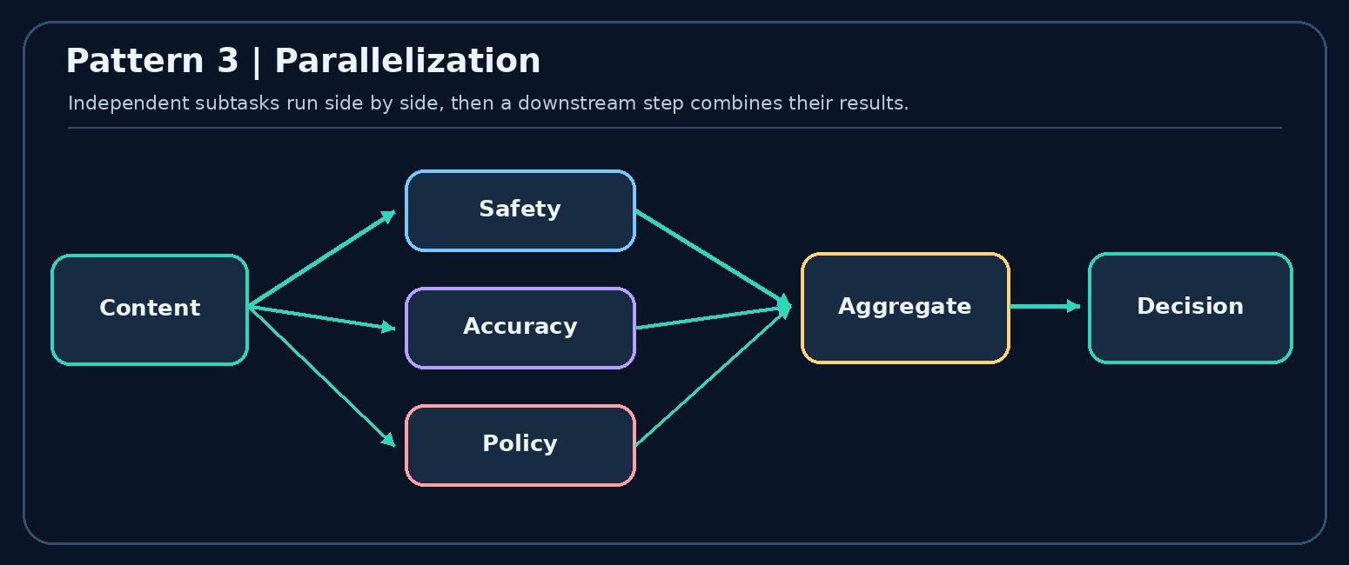
Figure 4. Parallel fan-out, followed by a join/aggregation step
When useful: independent tasks can run concurrently and you want lower wall-clock latency. Important: concurrency does not eliminate costs; individual LLM calls still consume tokens. If parallel branches update the same state key, you need a deliberate merge strategy (see reducers).

Fan-out, then fan-in
Suppose a report requires an accuracy review and a formatting review. Both can receive the draft at the same time. Their outputs can then be merged before the final approval node runs. The branches are independent, but the join must know what information each produced.
Parallel reviewer | State update | Why it can run independently
Accuracy | accuracy_score=8 | Reads the draft, not formatting feedback
Style | style_score=9 | Reads the draft, not the accuracy score
Finalizer | final_score=8.5 | Runs after both scores are available
If both workers write different keys, the results can coexist. If they both write notes in the same round, define a reducer such as list concatenation to avoid a conflicting concurrent write.

6. Orchestrator-workers 16:11
Idea: An orchestrator decides the subtask decomposition at runtime and delegates work to specialist workers. In a research task, it may choose literature retrieval, web reporting, and numerical analysis depending on the question, then synthesize the findings.
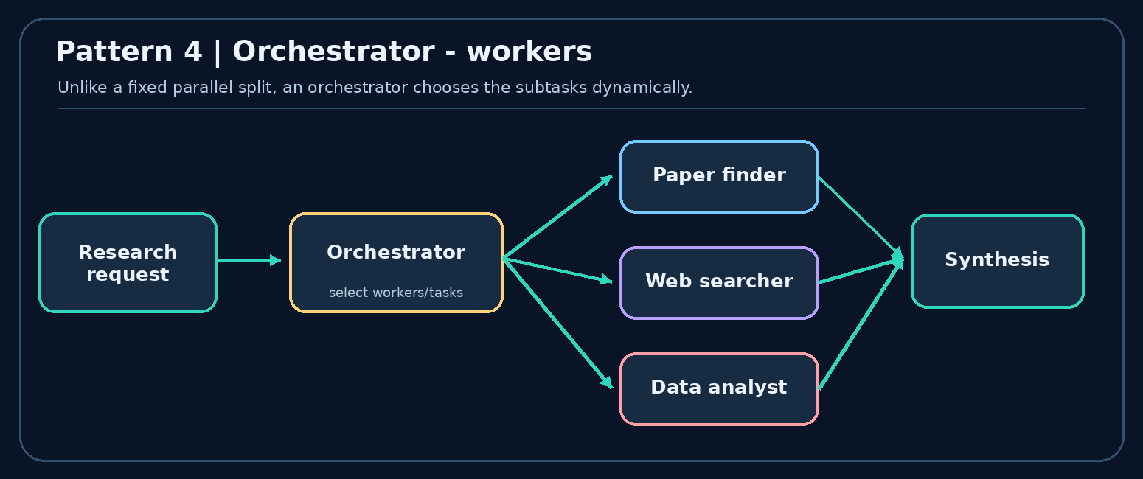
Figure 5. Dynamic task planning and worker delegation
Parallelization vs orchestrator-workers: in a simple parallel workflow, the set of branches is often predefined; with an orchestrator, the required tasks/workers can change from one request to another. Workers may execute concurrently, but the defining feature is dynamic delegation, not parallelism itself.

Fixed workers vs dynamically planned workers
Fixed parallelism: every report always runs exactly two checks - facts and style. Orchestrator-workers: for a market study, an orchestrator may create three competitor-analysis subtasks, while for a scientific review it may create five paper-analysis subtasks. The number and purpose of workers depend on the input.
Typical flow: Request → Planner/orchestrator → Worker tasks → Aggregate outputs → Final answer. In advanced LangGraph designs, Send can dispatch dynamically chosen units of work with their own task-specific state.
Guardrails: impose worker limits, timeouts and a total cost budget; require a common output format so the synthesis step can combine results reliably.

7. Evaluator-optimizer 19:48
Idea: Separate generation from evaluation. A generator produces a draft, an evaluator checks it against a rubric, and the generator improves it using feedback. The loop ends when quality conditions are met or another explicit stop rule is reached.
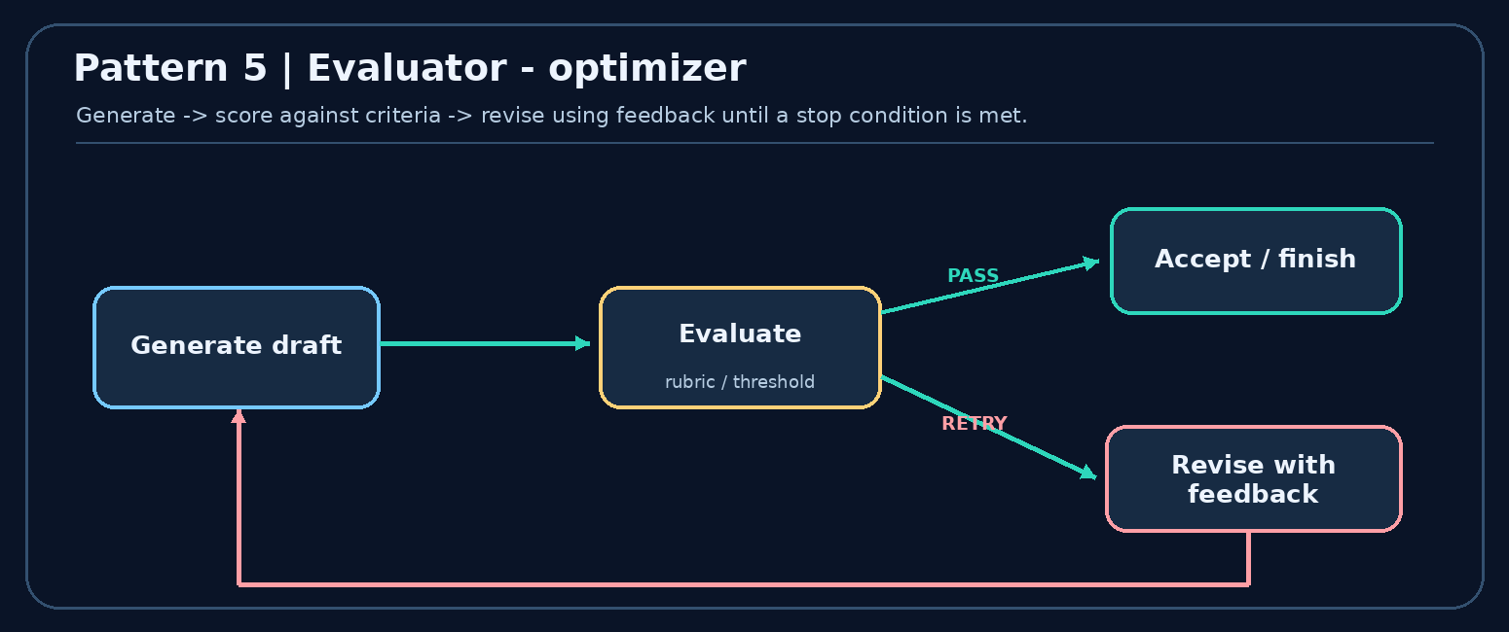
Figure 6. Iterative feedback loop with accept and retry branches
Example: generate a short essay -> score for clarity, reasoning and grammar -> if below threshold, provide specific feedback -> regenerate. Production tip: enforce a maximum number of iterations or a time/token budget so the system cannot retry indefinitely.

Understanding one evaluator loop
Round | Draft quality | Evaluator result | Next action
1 | Missing examples | score=5/10, feedback asks for examples | Revise
2 | Examples added | score=7/10, reasoning still weak | Revise
3 | Clear explanation | score=9/10 | Finish
A conditional edge can route to revise while the score is below a threshold, or to END once accepted. Always include a stopping rule, such as score >= 8 or attempts >= 3, because feedback loops need not converge automatically.
Pitfall: using the same LLM to generate and evaluate can create blind spots. For important tasks, supplement the evaluator with deterministic checks, a second model or human review.

8. Graphs, nodes, and edges 23:00
A graph is a set of vertices (nodes) connected by edges. In LangGraph:
- Node: a Python function/callable that reads current state, does one task, and returns state updates.
- Edge: a transition controlling which node(s) run next.
- START / END: special markers representing graph entry and termination.
- Conditional edge: a route chosen from a function’s output.
- Loop: an edge that returns to an earlier task when another attempt is needed.

Teaching example: essay practice
A learner receives a topic and submits an essay. Independent evaluators score clarity, depth, grammar; a combine step produces an overall score. A threshold gate either ends with a success message or returns feedback for another attempt. This one example combines sequential, parallel, conditional, and iterative execution.
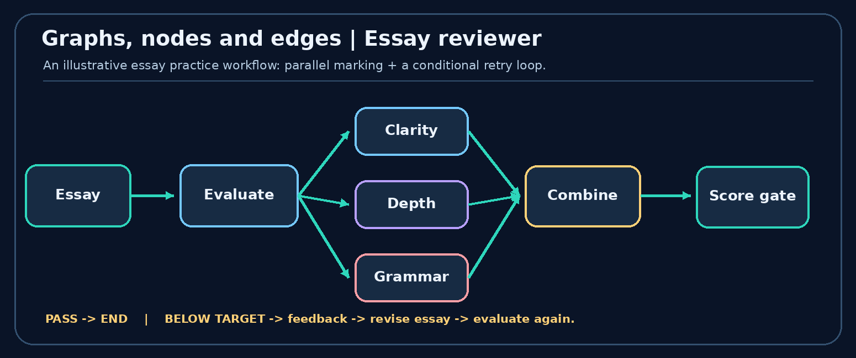
Figure 7. Simplified essay evaluation workflow inspired by the lesson
A useful distinction: the graph is the control-flow structure; state is the data that moves through the running process. Avoid confusing a connection arrow with a manually passed data object.

Node/edge exercise: follow an essay submission
Assume the essay graph is START → Draft → [Clarity, Grammar, Depth] → Aggregate → Decision. The bracketed nodes run in parallel, each returning a different score. The decision edge chooses either END or Revise → [Clarity, Grammar, Depth] for another round.
Trace:
State before scoring: {essay: "...", attempt: 1}
Clarity node returns: {clarity_score: 7}
Grammar node returns: {grammar_score: 9}
Depth node returns: {depth_score: 6}
State after merge: {essay: "...", attempt: 1,
clarity_score: 7, grammar_score: 9, depth_score: 6}
Aggregate returns: {overall_score: 7.33}
Only the updated fields need to be returned; each node need not rebuild and return the whole dictionary. A decision node should inspect the finished scores, not assume parallel results are available before the join.

9. Shared state 30:53
State is the evolving collection of values used by your workflow. In Python, a TypedDict is a common schema. For an essay evaluator, state might contain topic, essay, clarity_score, grammar_score, and overall_score.
Nodes read state and usually return partial updates. The runtime combines the updates into the state according to each key’s merge rule. State is a logical shared structure; it need not mean arbitrary Python global mutable memory.
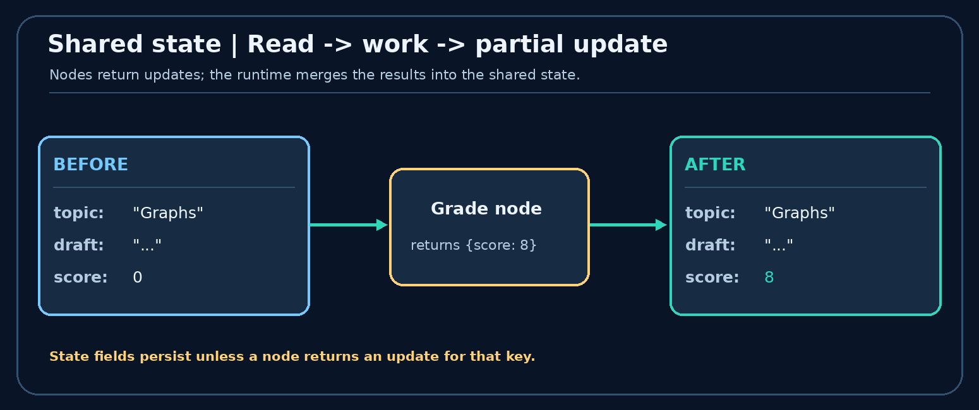
Figure 8. A node reads state and returns only the changed field
Illustrative state schema:
from typing import TypedDict
class EssayState(TypedDict):
topic: str
essay: str
score: float
def grade_essay(state: EssayState) -> dict:
# A toy score for illustration, not a real evaluation model.
new_score = 8.0 if len(state["essay"].split()) > 100 else 4.0
return {"score": new_score} # partial state update
Good practice: keep values that later nodes need; avoid storing unnecessary duplicated data. For real systems, separate raw inputs/outputs from transient prompt formatting.

A state-update example you can reason through
Initial state:
{"topic": "AI engineering", "essay": "first draft", "score": 0}
The grading node receives that state and returns only {"score": 8}. The runtime applies the update, so the new state is:
{"topic": "AI engineering", "essay": "first draft", "score": 8}
Why use a schema? It documents expected keys and types and helps organize node contracts. A Python TypedDict provides static typing guidance; it does not by itself validate every runtime value like a full validation model would.
Design tip: store stable business facts and references (candidate_id, essay, scores) rather than duplicating prompt-formatted strings. Prompts can be rebuilt by the node when needed.

10. Reducers 36:07
A reducer says how to combine a new write with an existing state value. By default, a state key is generally replaced by the newest update. Sometimes replacement is exactly right (for a scalar final score). At other times you want to accumulate data (chat history, essay revision history, parallel evidence).
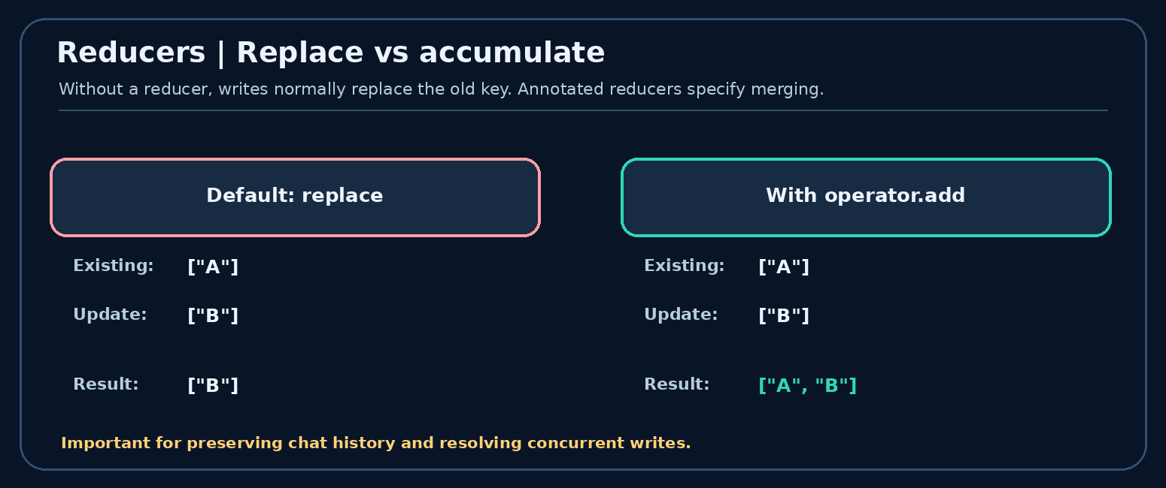
Figure 9. Replace an existing value versus append/accumulate writes
Reducer example (supplement):
from typing import Annotated, TypedDict
import operator
class NotesState(TypedDict):
events: Annotated[list[str], operator.add]
# If the old events list is ["start"] and a node returns
# {"events": ["outline ready"]}, operator.add produces:
# ["start", "outline ready"]
A list accumulator and a chat-message reducer are not identical. For production message history, LangGraph provides message-aware helpers (for example add_messages) that can also handle message IDs and replacement semantics. Parallel writes to the same key require a reducer or another valid coordination strategy, rather than assuming two branches can silently overwrite each other.

Reducer mechanics: replace vs accumulate
Suppose history=["draft 1"] already exists.
- Default replacement: node returns {"history": ["review 1"]} → new history becomes ["review 1"].
- List reducer (operator.add): the same update → new history becomes ["draft 1", "review 1"].
- Parallel reviewers: two nodes return ["grammar ok"] and ["clarity weak"]. A reducer lets the framework combine both updates into a list. Because parallel completion order need not define a meaningful order, do not depend on a particular order of entries in such a list.
Choosing a reducer: scores that should reflect the newest calculation often use replacement; history that should grow over time often uses accumulation. A chat message state may use add_messages, which handles message IDs and replacement semantics rather than blind list concatenation.
Easy mental test: ask, “When this field is written again, should old data be discarded or retained?” The answer guides your reducer.

Why reducers matter
- Conversation continuity: preserve prior messages instead of losing them with each turn.
- Revision history: retain each iteration of a document if needed.
- Parallel branches: safely combine writes made in the same execution round.

11. LangGraph execution model 44:38
The graph engine is inspired by Pregel, a graph-processing model associated with Google. The lesson presents execution in three broad phases:
1. Define: specify your state schema, node functions, and edges.
2. Compile: build an executable graph and validate supported structural constraints.
3. Invoke: provide an initial state, execute activated nodes, apply state updates, and activate downstream nodes.
Execution progresses in supersteps (rounds). A superstep can contain multiple independent nodes running concurrently. Their writes are gathered and reconciled for the next round. The process terminates when it reaches an end condition and no further tasks are scheduled.
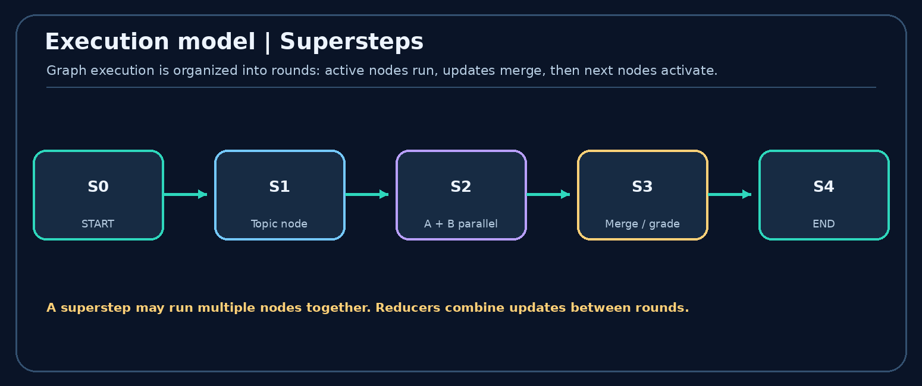
Figure 10. Supersteps: sequential rounds can include parallel execution
Important nuance: graph compilation checks the framework-level structure but cannot prove that every business decision or LLM result will be correct. Also, reliable pause/resume across sessions requires suitable checkpointing/persistence configuration; it does not happen simply because you drew a graph.

Pregel execution: why the graph runs in rounds
Each superstep determines which nodes are active, executes the activated work, and applies updates for the next round. Independent branches can run in the same round; downstream nodes see their combined updates in a later round.
Superstep 0: START schedules a draft node
Superstep 1: Draft writes essay, schedules reviewers
Superstep 2: Clarity + Grammar + Depth run in parallel
Superstep 3: Aggregate reads scores and writes overall_score
Superstep 4: Decision routes to END or Revise
This is a conceptual schedule: actual scheduling details vary by graph shape. The key insight is parallel tasks are synchronized through graph execution steps and merge rules.
What compile() does and does not do: it constructs an executable graph and validates certain graph constraints. It does not verify factual correctness, guarantee convergence, persist state without a configured checkpointer, or make external side effects safe by itself.
Persistence versus state: state is the working data of the graph. A checkpointer saves thread snapshots for recovery and resumption; a store can hold data reused across threads. These are separate features.

12. A tiny executable graph
The following uses deterministic nodes so you can understand graph structure without an API key. Use it to practice graph structure before adding model calls.
# pip install -U langgraph
from typing import TypedDict
from langgraph.graph import StateGraph, START, END
class StudyState(TypedDict):
topic: str
outline: str
answer: str
def outline_node(state: StudyState) -> dict:
return {"outline": f"Definition + example + pitfalls for {state['topic']}"}
def answer_node(state: StudyState) -> dict:
return {"answer": f"Study notes: {state['outline']}"}
builder = StateGraph(StudyState)
builder.add_node("outline", outline_node)
builder.add_node("answer", answer_node)
builder.add_edge(START, "outline")
builder.add_edge("outline", "answer")
builder.add_edge("answer", END)
app = builder.compile()
result = app.invoke({"topic": "LangGraph", "outline": "", "answer": ""})
print(result["answer"])
Try changing the graph: add a check_node between outline and answer; add a second branch; or use a reducer on a list key. These are natural next exercises after this conceptual lecture.

Extend the example with real routing (still no API key)
This second example is intentionally deterministic. It makes conditional edges visible without involving model output.
from typing import TypedDict
from langgraph.graph import StateGraph, START, END
class ReviewState(TypedDict):
essay: str
result: str
word_count: int
def count_words(state: ReviewState):
return {"word_count": len(state["essay"].split())}
def decide(state: ReviewState):
return "pass" if state["word_count"] >= 15 else "revise"
def passed(state: ReviewState):
return {"result": "Minimum length achieved"}
def revise(state: ReviewState):
return {"result": "Add more explanation and examples"}
builder = StateGraph(ReviewState)
for name, node in [("count", count_words), ("pass", passed), ("revise", revise)]:
builder.add_node(name, node)
builder.add_edge(START, "count")
builder.add_conditional_edges("count", decide, {"pass": "pass", "revise": "revise"})
builder.add_edge("pass", END)
builder.add_edge("revise", END)
app = builder.compile()
print(app.invoke({"essay": "This is short", "result": "", "word_count": 0})["result"])
Exercise: change the rule from 15 words to 25 and invoke again. Then add a node that appends helpful feedback, using a reducer rather than replacing a feedback list. For durable work, learn InMemorySaver for local experiments, then a database-backed checkpointer.

13. One-page comparison and exam revision
- Workflow: end-to-end task decomposition. What goal are the steps achieving?
- Prompt chain: a fixed dependent series. Is the order known?
- Routing: choose a path. Which handler fits this input?
- Parallelization: concurrent independent jobs. Can these tasks run together?
- Orchestrator-workers: dynamic delegation. Must subtasks be planned at runtime?
- Evaluator-optimizer: generate, judge, improve. When does the loop stop?
- Node: a task implementation. What does the function read and write?
- Edge: a next-step transition. What runs after this task?
- State: evolving shared values. Which fields are needed later?
- Reducer: a state-update merge rule. Replace, append or combine?
- Superstep: an execution round. Which nodes run together?

A build-from-scratch learning path
- Sketch the graph on paper before writing code. Mark every branch and possible loop.
- Define the state schema (TypedDict) with fields other nodes need.
- Write one node per responsibility; return partial dictionaries rather than mutating an unrelated global variable.
- Connect edges, including START, END, and any decision paths.
- Compile and invoke with simple deterministic test inputs first.
- Add persistence/interrupts only when your use case requires stopping and resuming.
- Inspect runs and test failure cases: wrong route, empty input, conflicting writes, too many loop iterations, and retry of an external action.
Suggested project: build an essay coach that generates a revision checklist, scores three dimensions, routes to feedback if the score is low, and records each revision attempt. Use dummy scoring functions first, then swap in model calls.

Quick self-test
- ☐ Explain node vs edge vs state in one sentence each.
- ☐ Draw all five workflow patterns from memory.
- ☐ Explain fixed parallel workers vs dynamic orchestrator workers.
- ☐ Explain why concurrent state updates sometimes need a reducer.
- ☐ Draw a feedback loop and name its stopping condition.
- ☐ Explain how supersteps relate to parallel execution.
- ☐ Build the three-node START -> outline -> answer -> END graph yourself.

Common mistakes to avoid
Mistake 1: “Every LangGraph node needs an LLM.” Not true - a node may be any supported computation.
Mistake 2: “State means durable long-term memory automatically.” State holds working data; durability is a separate checkpointing concern.
Mistake 3: “Parallel worker branches can freely overwrite the same key.” Merge behavior must be defined.
Mistake 4: “A router and an orchestrator are the same.” Routing chooses a path; orchestration may decompose a job into a dynamic set of tasks.
Mistake 5: “An evaluator loop is guaranteed to converge.” Always impose stop conditions and budgets.

Further reading
- CampusX lesson - LangGraph Core Concepts
- LangGraph Graph API overview
- Workflow and agent patterns
- Persistence: checkpoints versus stores
- Interrupts and resuming a thread
- Thinking in LangGraph

